CONTEXT AND EXECUTION OF SCRIPT
We are currently conducting a study on space data accessibility, examining the ease of how open-source Earth Observation datasets are accessed under different real-world network conditions. The study uses wildfire space data retrieved from three major archives: NASA Earthdata, NASA FIRMS, and the ESA Copernicus Space Data Ecosystem.
The objective is to measure the download and performance metrics to better understand how infrastructure differences affect access to data that underpins disaster mitigation. The broader goal is to generate evidence that supports more equitable and globally inclusive data systems.
CONTEXT AND EXECUTION OF SCRIPT
The script is provided in a zip file and is run in the Python Spyder environment. It automatically accesses the three archives and records download metrics. No coding is required from participants.
Instructions:
- Create archive credentials for: FIRMS, Earthdata and Copernicus Data Space Ecosystem
- Extract the zip file.
- Open “Accessibility Script.py” in Spyder.
- Run the script and input 30 when prompted for the number of iterations.
The script typically runs for 5–10+ hours depending on location and connection speed. The computer must remain connected to stable, unlimited Wi-Fi, with the screen active. VPNs must not be used, as they can distort latency measurements. The script does not require significant storage space.
Upon completion, an Excel file titled “combined_latency_YYYYMMDD_HrMinSec” will be generated in the extracted folder. The output file can then be sent to: exk419@student.bham.ac.uk.
PLEASE DO STATE THE CITY AND COUNTRY YOU RUN THE SCRIPT IN.
If any issue occurs before entering the number of iterations, please consult the “Readme.txt” file in the folder (approx. 4-minute read). For further questions, I am available via LinkedIn or email. In case the user has no prior skill of python, the next page is a step-by-step guide on how to get Anaconda-Spyder software and running of the script.
Thank you for your consideration and support in strengthening global access to critical space data.
Emmanuel Karikari
University of Birmingham
ACCOUNT REGISTRATION AND ACCESS SETUP
Before running the script, complete the steps below for each data service you will test. If you already have an account, sign in to confirm that it works.
For FIRMS, there is no need to register as the script draws directly from a set of links.

NASA EARTHDATA - CREATE AN EARTHDATA LOGIN
Earthdata Login provides access to NASA Earth science data services.
Step 1: Open:
https://urs.earthdata.nasa.gov/
Step 2: Click “Register”.
Step 3: Complete the required fields, choose a username and create a password. Keep a record of your username: do not assume that it is your email address.
Step 4: Submit the registration form.
Step 5: Open the activation email from Earthdata and click the activation link. Your account must be activated before you can sign in.
Step 6: Return to the Earthdata Login page and sign in to confirm that the account works.
Credentials to keep privately:
- Earthdata username
- Earthdata password
Step 7: Save your Earthdata username and password in the ‘earthdata_credentials’ text file. Replace ‘USERNAME_HERE’ with your username, and ‘PASSWORD_HERE’ with your password.
Step 8: After signing in, open “Generate Token” in your profile and follow the instructions. Use “Show Token” to view and copy it into the ‘earthdata_token.
(Please note: Earthdata user tokens work with compatible applications and currently expire after 60 days. Check the expiry date and replace the token when necessary.)

COPERNICUS DATA SPACE ECOSYSTEM (CDSE) - CREATE AN ACCOUNT
Step 1: Open:
https://dataspace.copernicus.eu/
Step 2: Click the 'login’ icon near the top-right corner, select “Your profile” tab, then select “Register”.
Step 3: Complete the required information, enter your email address and create a password.
Step 4: Read and accept the required terms and privacy policy, then submit the registration form.
Step 5: Open the verification email and click “Verify email address”. Check your spam or junk folder if necessary.
Step 6: Return to the CDSE website and sign in using your registered email address and password.
Credentials to keep privately:
- CDSE email address
- CDSE password
Step 7: Save your CDSE username and password in the ‘cdse_credentials’ text file. Replace ‘USERNAME_HERE’ with your username, and ‘PASSWORD_HERE’ with your password.
Registration guide:
https://documentation.dataspace.copernicus.eu/Registration.html

BEFORE RUNNING THE SCRIPT
Confirm that:
- Your Earthdata account is activated, and you can sign in.
- Your CDSE email is verified, and you can sign in.
- You have entered and saved the required credentials and token in the appropriate text files.
Keep passwords, API keys and tokens private. Do not upload them to GitHub or include them in shared results, screenshots or error reports. Any local files containing credentials must be excluded from GitHub tracking.

HOW TO INSTALL SPYDER AND RUN THE SCRIPT.
- Extract the SCRIPT.ZIP onto your desktop/document folder.
- Go to Download Anaconda Distribution | Anaconda select “Skip to download” under the green “Get started with Anaconda Distribution” botton and download Anaconda Distribution. (Note: If you wish, you can sign up using an email or a using Gmail, Microsoft or GitHub account)
- Select and install the ‘Anaconda’ software after downloading.
- After installation, select ‘Anaconda Navigator’ from your Windows start menu/search, if Anaconda does not open after installation.
- Select the launch button of ‘SPYDER’ from the suite selection of Anaconda Navigator.
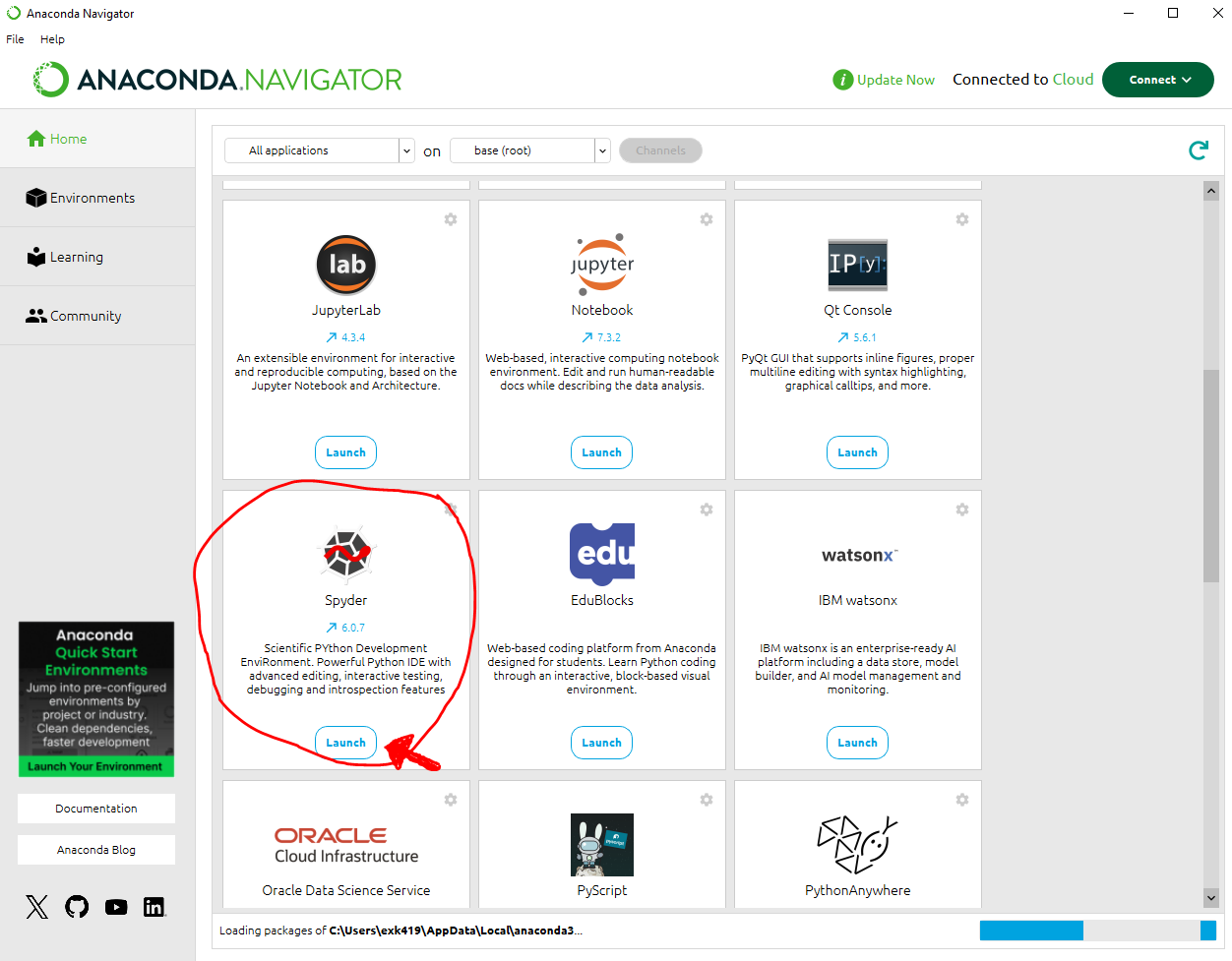
- Once launched (might take a couple of minutes), select the ‘open folder’ button on the top left.
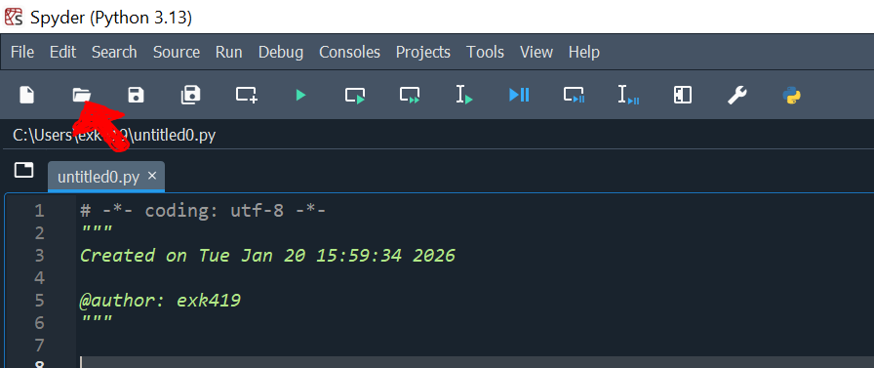
- Navigate to the extracted script folder and select ‘Latency Script’ and open.
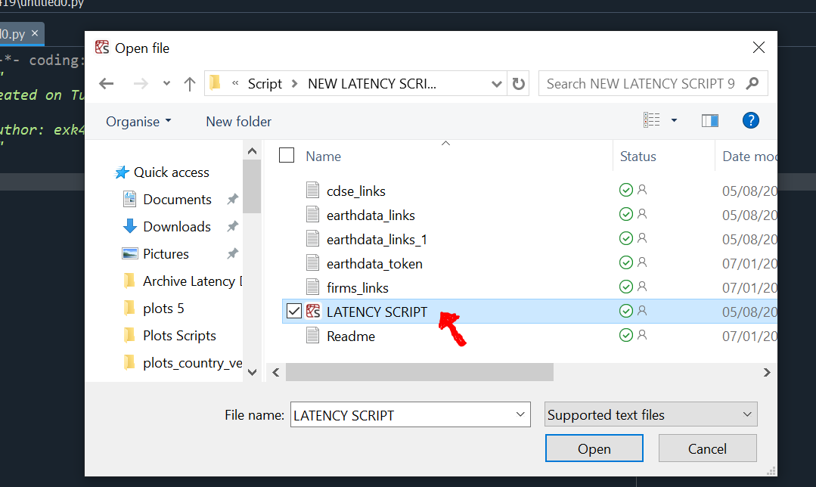
- The script will load and be displayed in the Main Quadrant (box). Press the ‘play button’
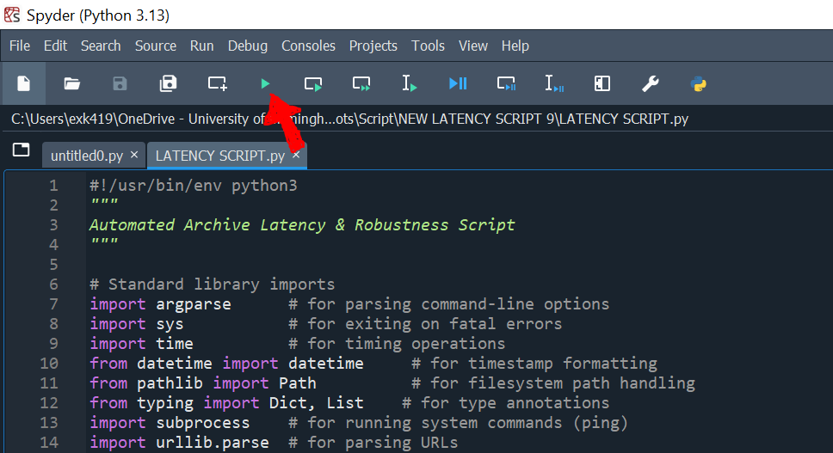
- Now input/type – 30 in the bottom right quadrant and press enter.
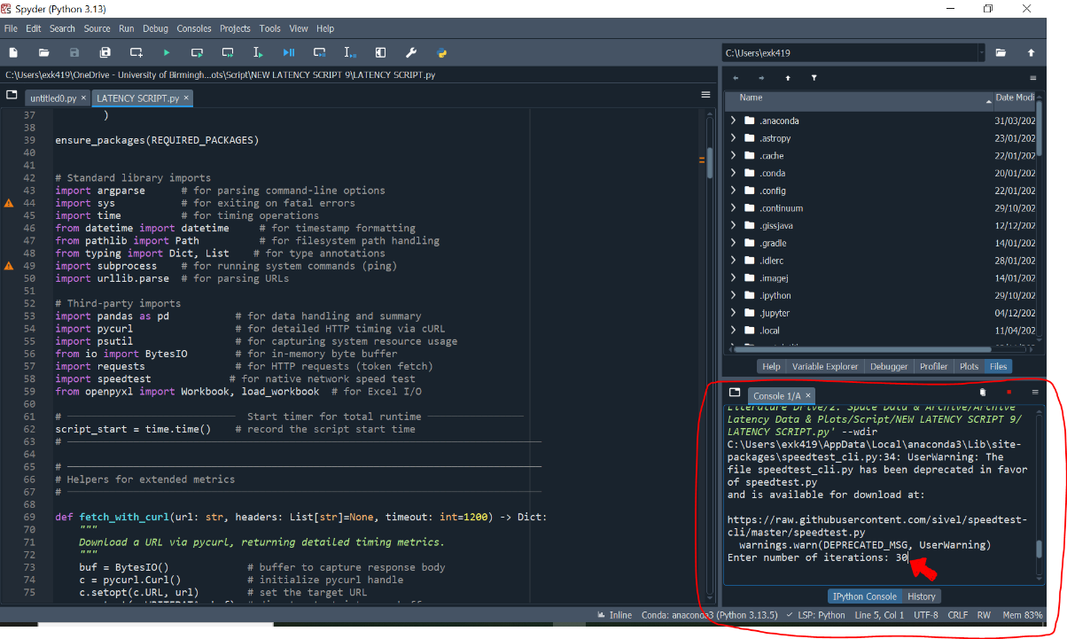
- The script will run for some hours, and the computer/laptop should be left on with its screen on throughout to complete it.
- To keep your computer on for the whole duration:
For Windows OS:
- Go to the main desktop screen: right-click select ‘Personalise’ (if not available- select properties) select ‘Lock screen' (on the left) scroll down and select ‘Screen timeout settings’.
- Now select ‘Never’ from the drop downs for the following:
Screen [When plugged in, turn off after] ‘Never’,
Sleep [When plugged in, turn off after] ‘Never’.
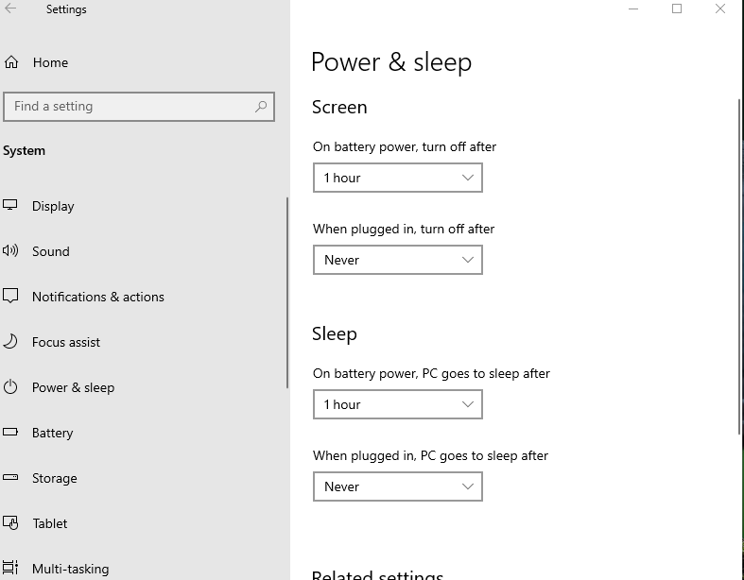
END.

